15 June
Mainly wrestling with problems caused by getting out of gitsync.

Recent changes include
- The use of speedUpFactor as a parameter
- Mending the broken-stick function. This is now as it was originally.
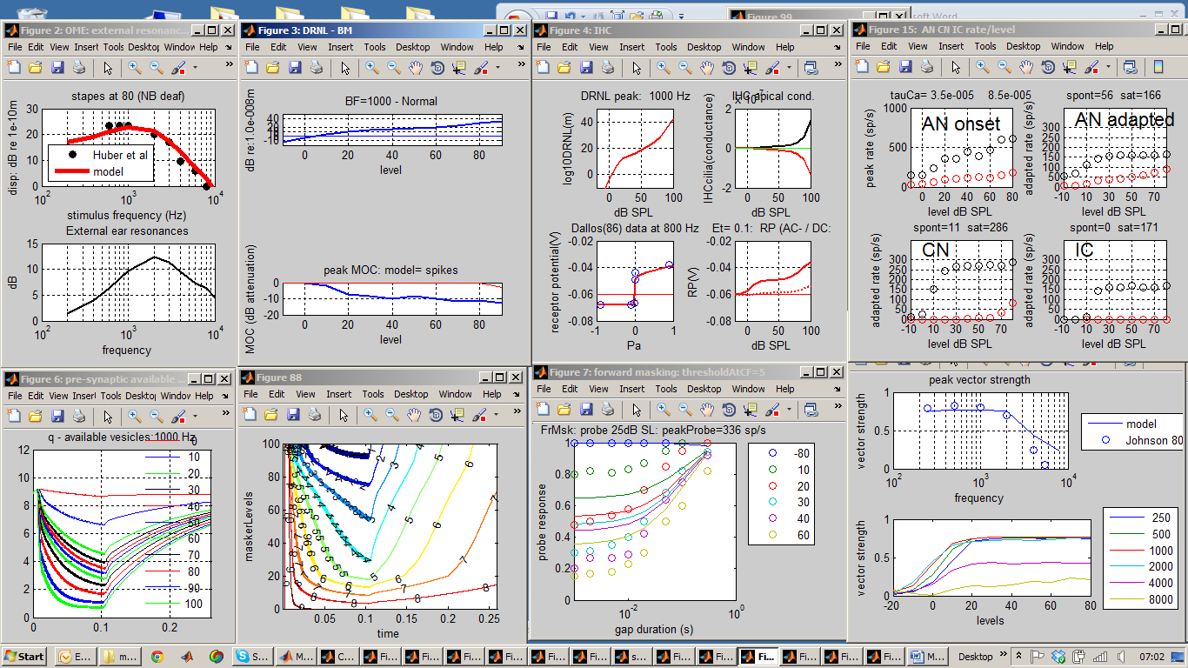
Diagnosis:
- Synapse is not flat at lowest level
- Forward masking is not strong and recovers too quickly.
- Too much phase locking at 8 kHz
Other changes
- Test_MAP simplified to remove mixer files
- showMAP options now default if missing
- showMAP is now UTIL_showMAP and stored in utilities
- UTIL_showMAP now does not show plotdivider for only one fiber type
- New userPrograms folder created
- Claim ID: 2JiVXk4jaSr430i1
- Claim Passcode: tChKEDTEhgVphqFc

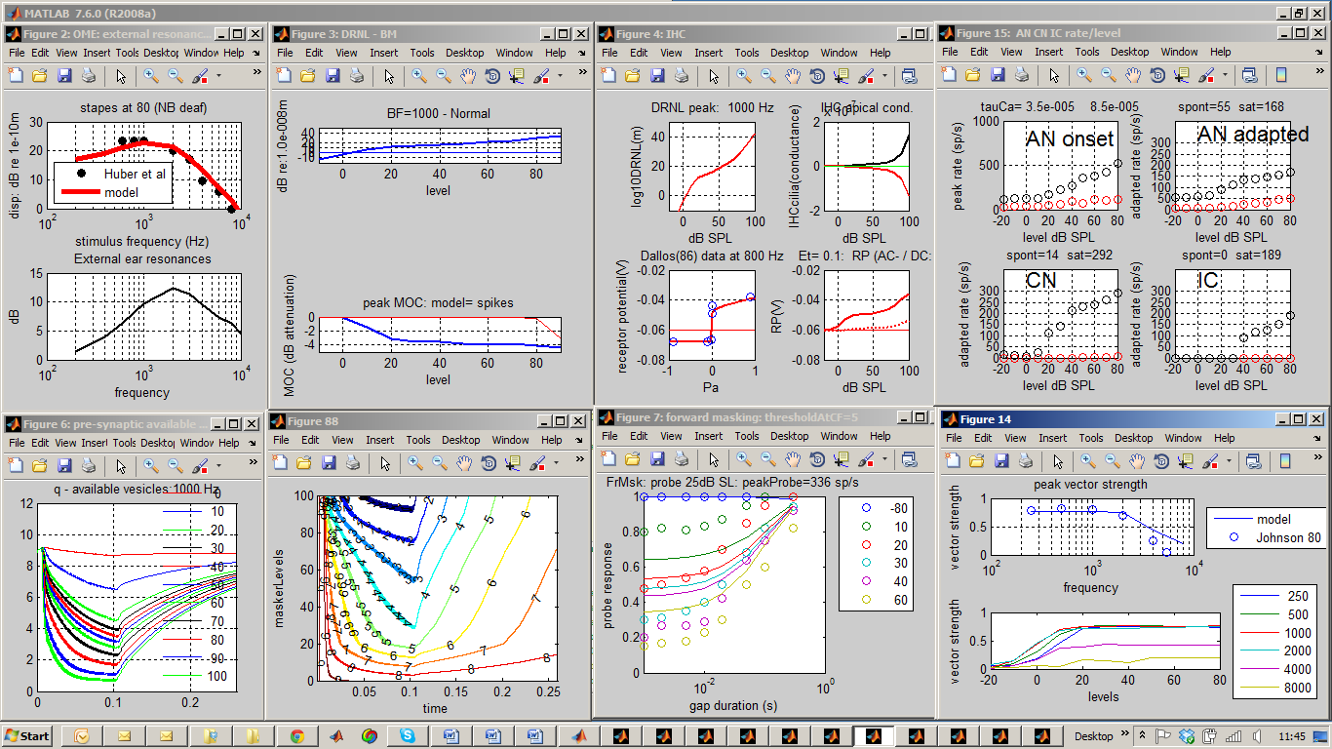
Diagnosis:
AN not saturating, too little FM, IC threshold too high,
NB phase locking estimates are the largest across all levels. This will be an overestimate in the case of 8 kHz where no phase-locking is expected; i.e. it cannot be less than zero so must be biased.

Other changes
testBM: tuning curves reduced to bottom row
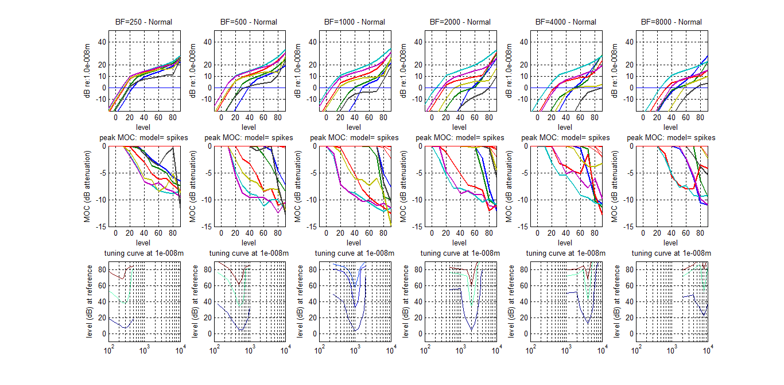
Diagnosis: at high signal levels, the filters are not as wide as they might be. Perhaps g should be greater if this is compatible with patient data.

More changes
Test_Map1_14: (PATH PROBLEMS)
Add: addpath (['..' filesep 'utilities']) to line 145
Remove: path(restorePath) from line 149
Problem:
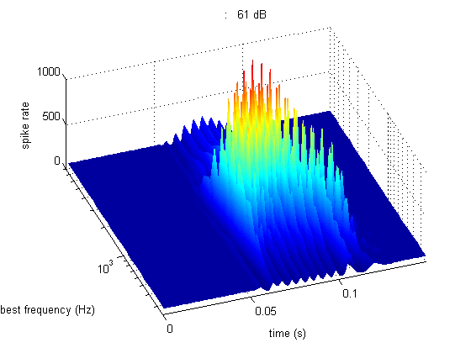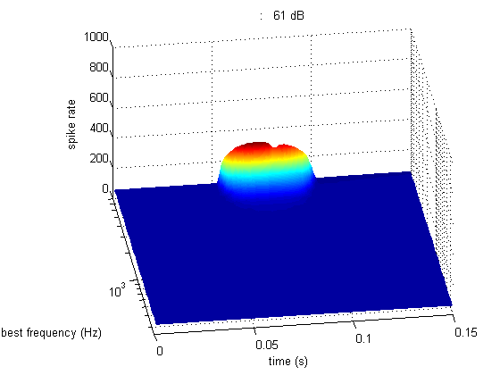
Lots of problems. Also tone should be 10 ms with 20 ms silence

June 16

Minor changes
- Path problems in test programs sorted (UTIL_showMAP).
- Improved comments in UTIL_showMAP
- Checked and working well with expGUI
- Saved as “MAP1_14f - 16 June works”
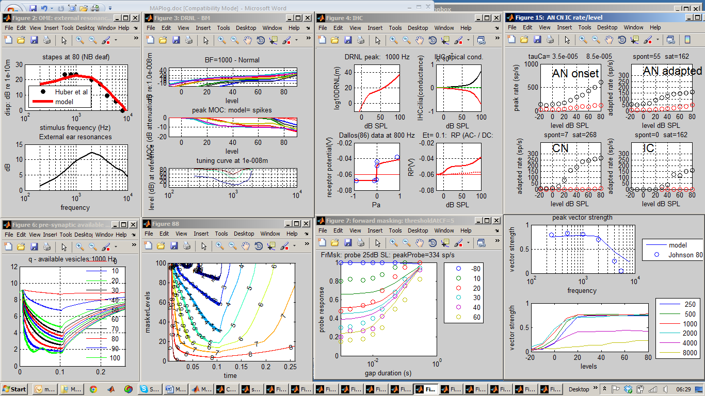

More changes
- testBM figure located
- testPhaseLocking figure located and test levels reduced to range 50-80 dB SPL
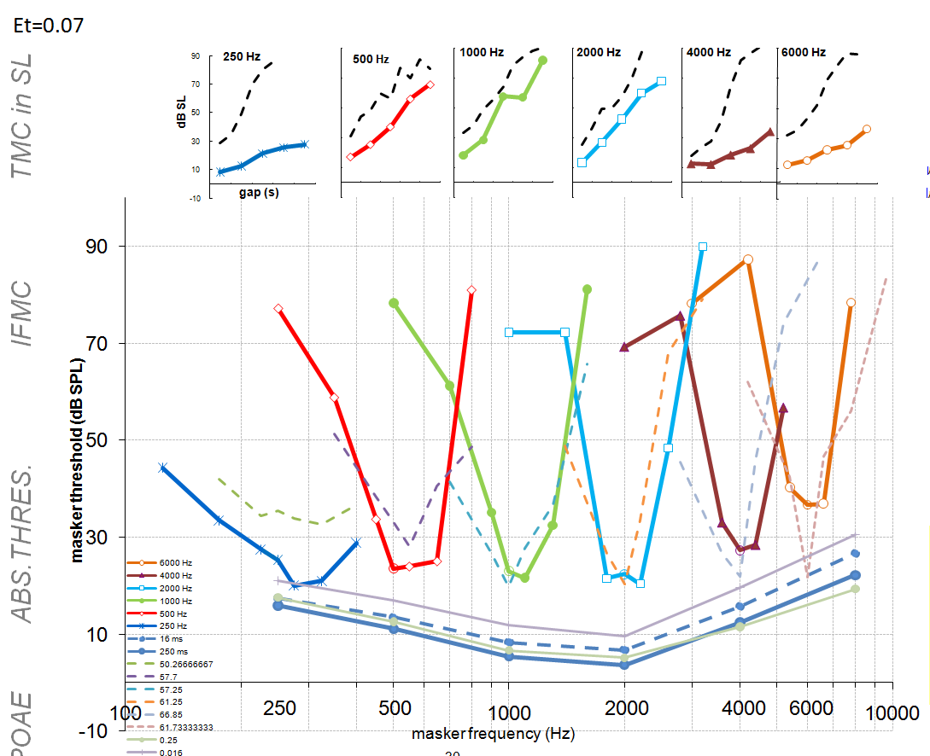
Saved as data and reports\parameter fitting\17 June 2011 profiles
Et= 0.07 a=0

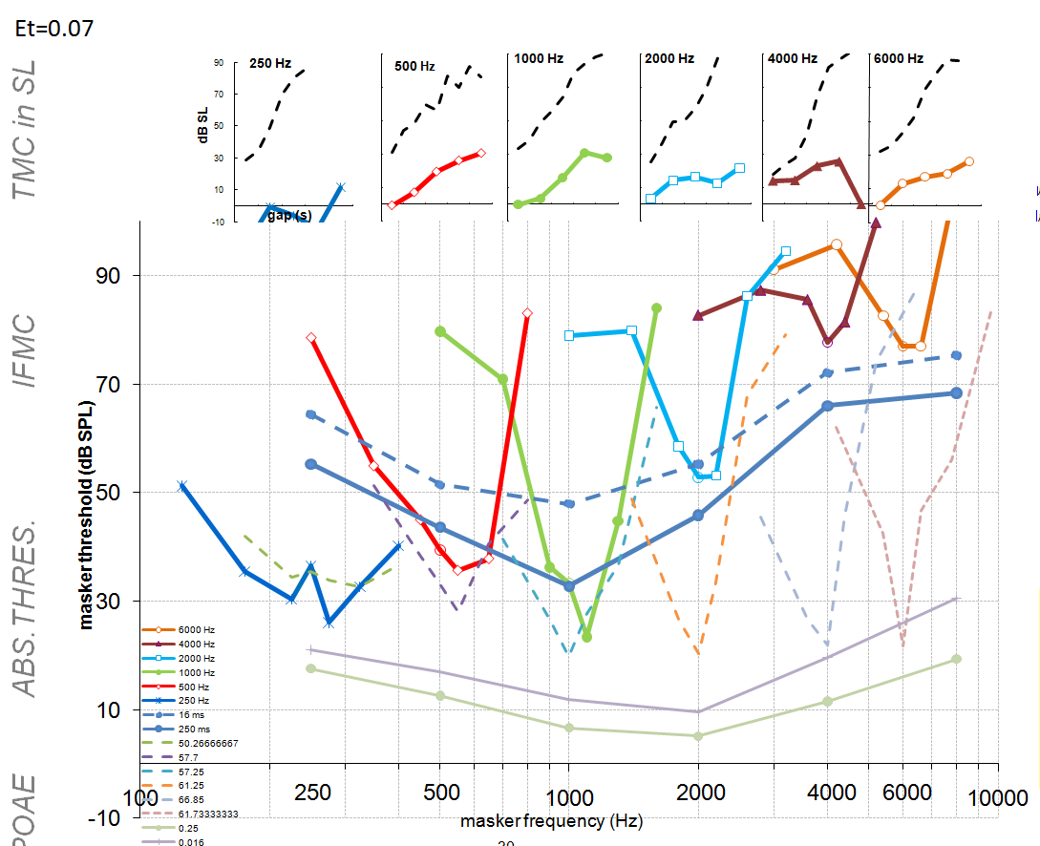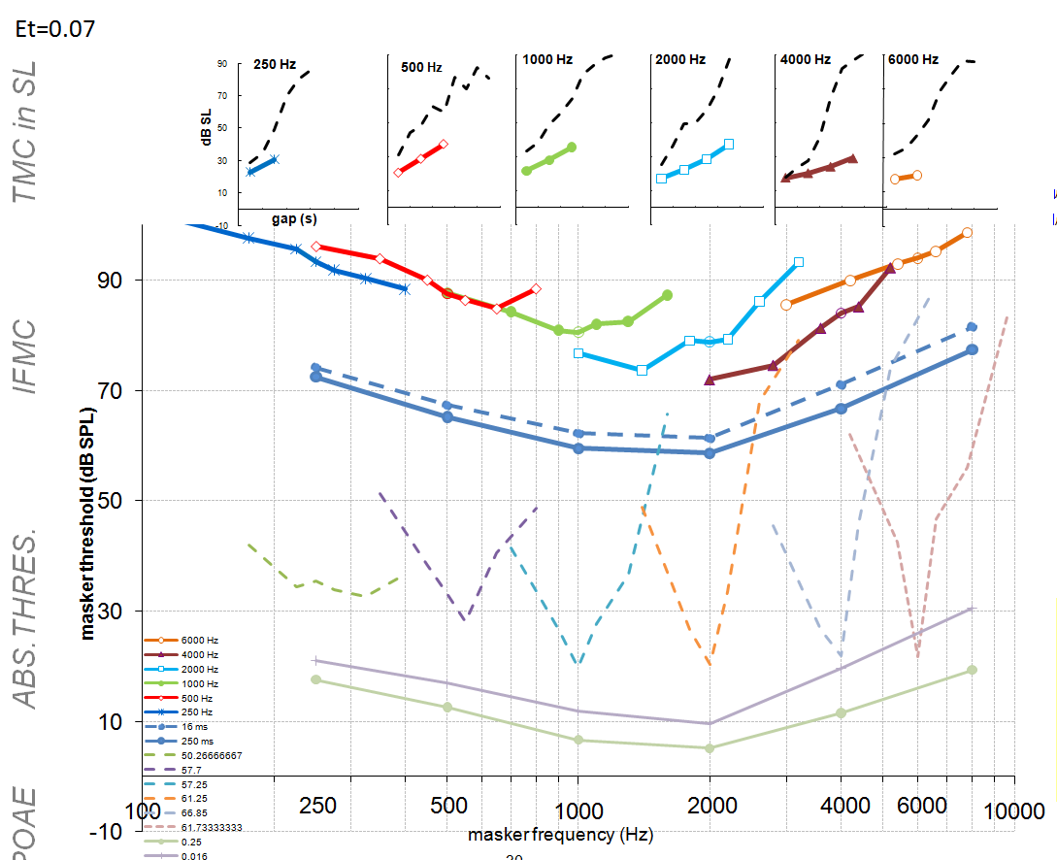

Diagnosis
- continued weakness at HF and VLF for TMC
- Et=0.07 shows gratifying HF loss.
- Odd 250-Hz IFMC for Et=0,07
- A=0: TMCs are too steep. This may agree with forward masking results showing premature recovery (see above)
- Small 16-250 ms threshold gap for normal. This may relate to high compression threshold or inappropriate threshold in CN/IC.
Treatment
- Slow down recovery using ‘y’
- Check out IC threshold
- Note other problems with rapid onsets for speech stimuli. Possible problem with RP (check logbook)

Minor changes
- Path problem in test_MAP1_14 resolved
- New parameter set uder trial in NormalTest

%% #4 IHC_cilia_RPParams

IHC_cilia_RPParams.tc= 0.0003; % 0.0003 filter time simulates viscocity
% IHC_cilia_RPParams.tc= 0.0005; % 0.0003 filter time simulates viscocity
IHC_cilia_RPParams.C= 0.01; % 0.1 scalar (C_cilia )
IHC_cilia_RPParams.u0= 5e-10;
IHC_cilia_RPParams.s0= 10e-10;
IHC_cilia_RPParams.u1= 5e-10;
IHC_cilia_RPParams.s1= 5e-10;

IHC_cilia_RPParams.Gmax= 4e-9; % 2.5e-9 maximum conductance (Siemens)
IHC_cilia_RPParams.Ga= 1.5e-9; % 4.3e-9 fixed apical membrane conductance

% #5 IHC_RP
IHC_cilia_RPParams.Cab= 4e-012; % IHC capacitance (F)
IHC_cilia_RPParams.Cab= 1e-012; % IHC capacitance (F)
IHC_cilia_RPParams.Et= 0.100; % endocochlear potential (V)

IHC_cilia_RPParams.Gk= 2e-008; % 1e-8 potassium conductance (S)
IHC_cilia_RPParams.Ek= -0.08; % -0.084 K equilibrium potential
IHC_cilia_RPParams.Rpc= 0.04; % combined resistances

%% #5 IHCpreSynapse
IHCpreSynapseParams=[];
IHCpreSynapseParams.GmaxCa= 14e-9;% maximum calcium conductance
IHCpreSynapseParams.GmaxCa= 12e-9;% maximum calcium conductance
IHCpreSynapseParams.ECa= 0.066; % calcium equilibrium potential
IHCpreSynapseParams.beta= 400; % determine Ca channel opening
IHCpreSynapseParams.gamma= 100; % determine Ca channel opening
IHCpreSynapseParams.tauM= 0.00005; % membrane time constant ?0.1ms
IHCpreSynapseParams.power= 3;
% reminder: changing z has a strong effect on HF thresholds (like Et)
IHCpreSynapseParams.z= 1e42; % scalar Ca -> vesicle release rate

LSRtauCa=35e-6; HSRtauCa=85e-6; % seconds
% LSRtauCa=35e-6; HSRtauCa=70e-6; % seconds
IHCpreSynapseParams.tauCa= [LSRtauCa HSRtauCa]; %LSR and HSR fiber

%% #6 AN_IHCsynapse
% c=kym/(y(l+r)+kl) (spontaneous rate)
% c=(approx) ym/l (saturated rate)
AN_IHCsynapseParams=[]; % clear the structure first
AN_IHCsynapseParams.M= 12; % maximum vesicles at synapse
AN_IHCsynapseParams.y= 3; % depleted vesicle replacement rate
% AN_IHCsynapseParams.y= 6; % depleted vesicle replacement rate

AN_IHCsynapseParams.x= 10; % replenishment from re-uptake store
AN_IHCsynapseParams.x= 60; % replenishment from re-uptake store

% reduce l to increase saturated rate
AN_IHCsynapseParams.l= 150; % *loss rate of vesicles from the cleft
% AN_IHCsynapseParams.l= 250; % *loss rate of vesicles from the cleft

AN_IHCsynapseParams.r= 500; % *reuptake rate from cleft into cell
% AN_IHCsynapseParams.r= 300; % *reuptake rate from cleft into cell

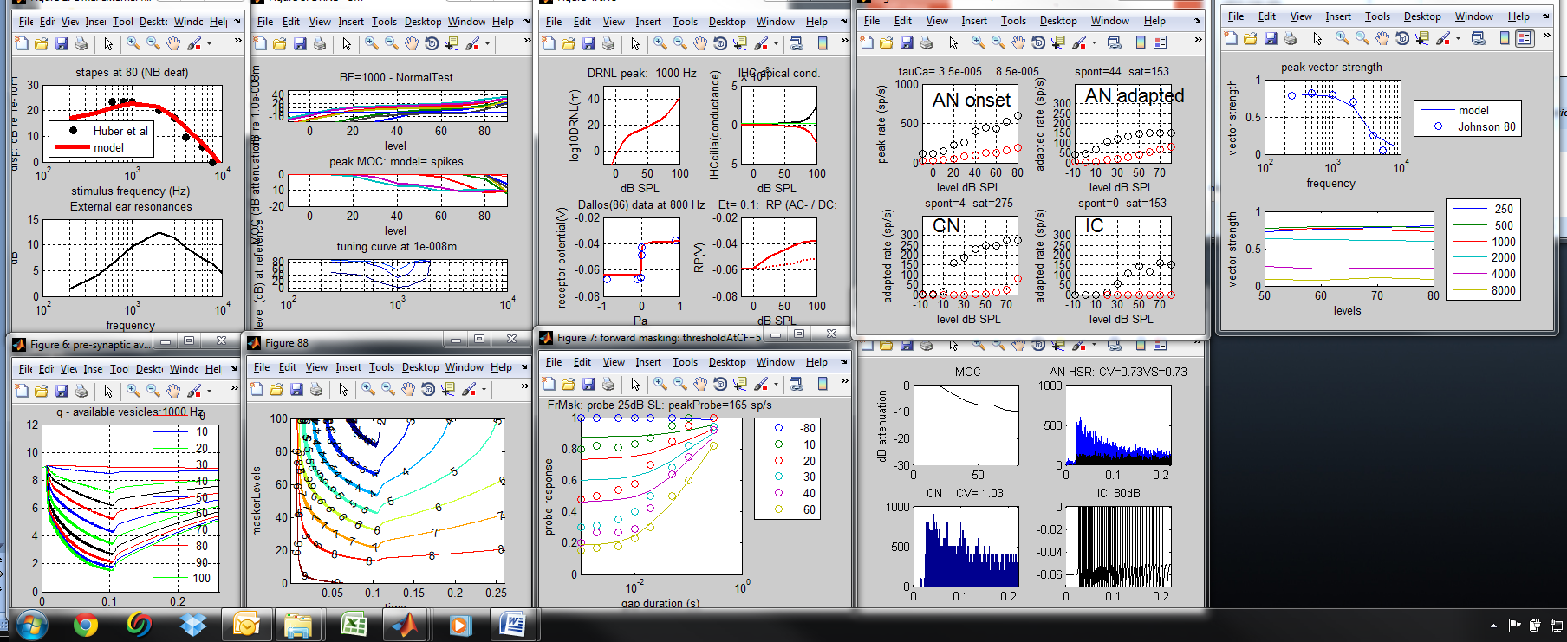
But this gives very shallow TMC y=4
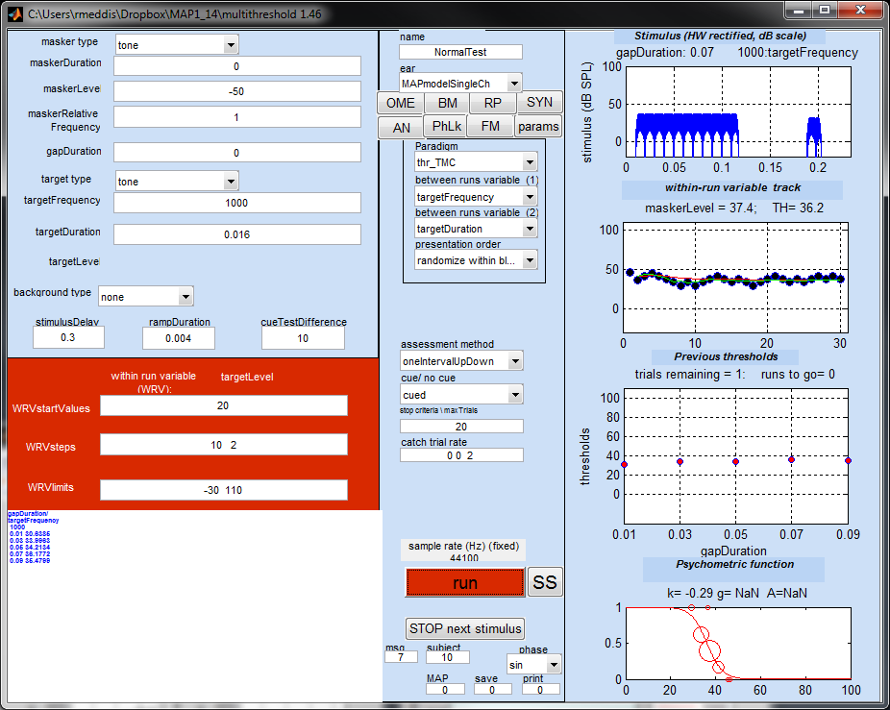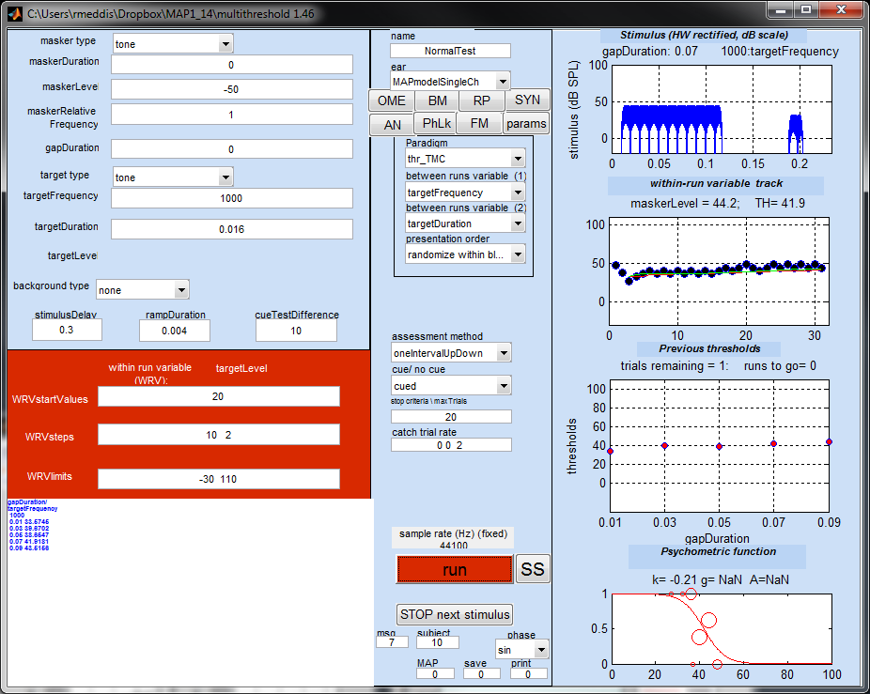
Y=5 y=6
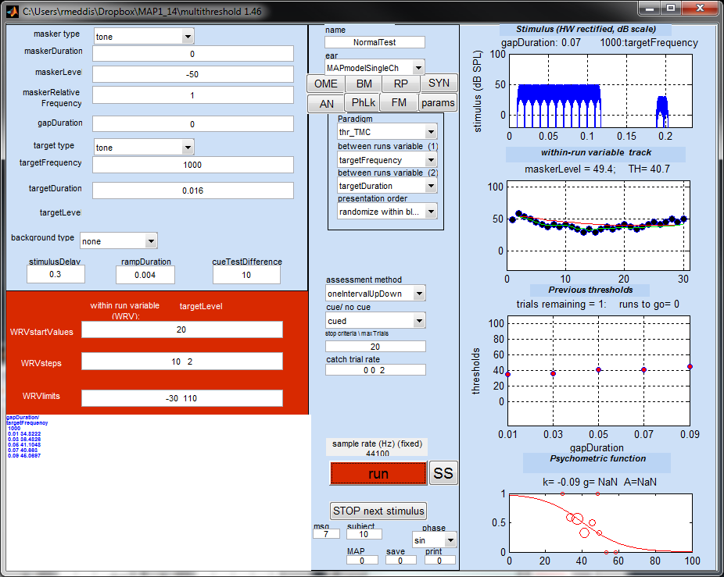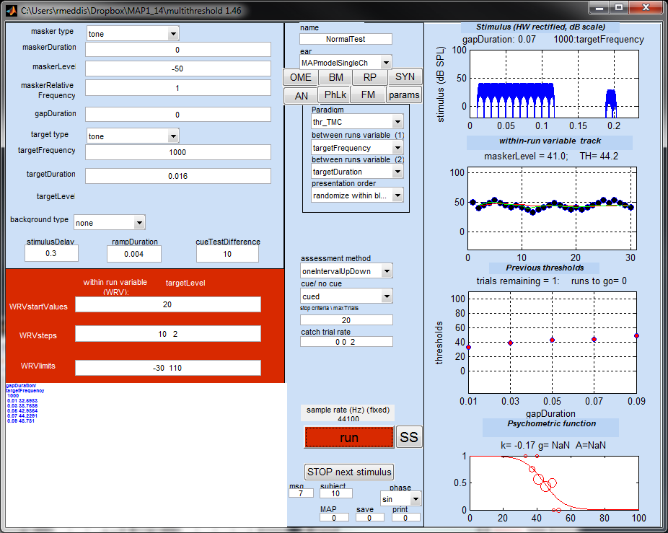
Y=7
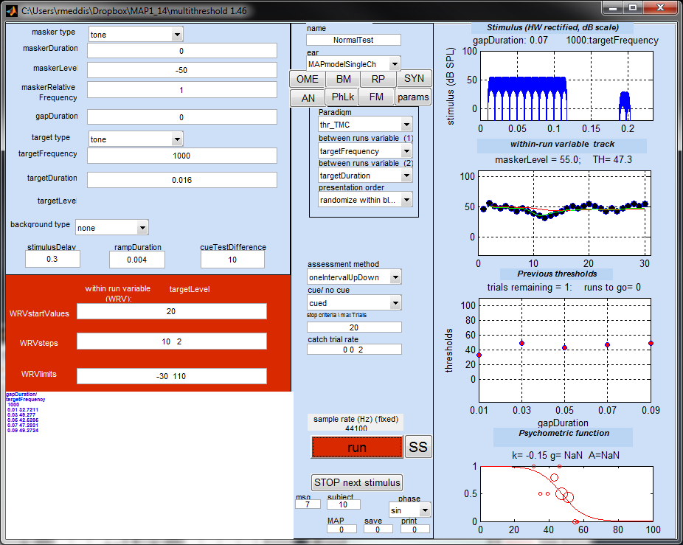
The problem might be caused by an inappropriate compression threshold. Using a higher probe level we get (y=7)

Probe+10 dB
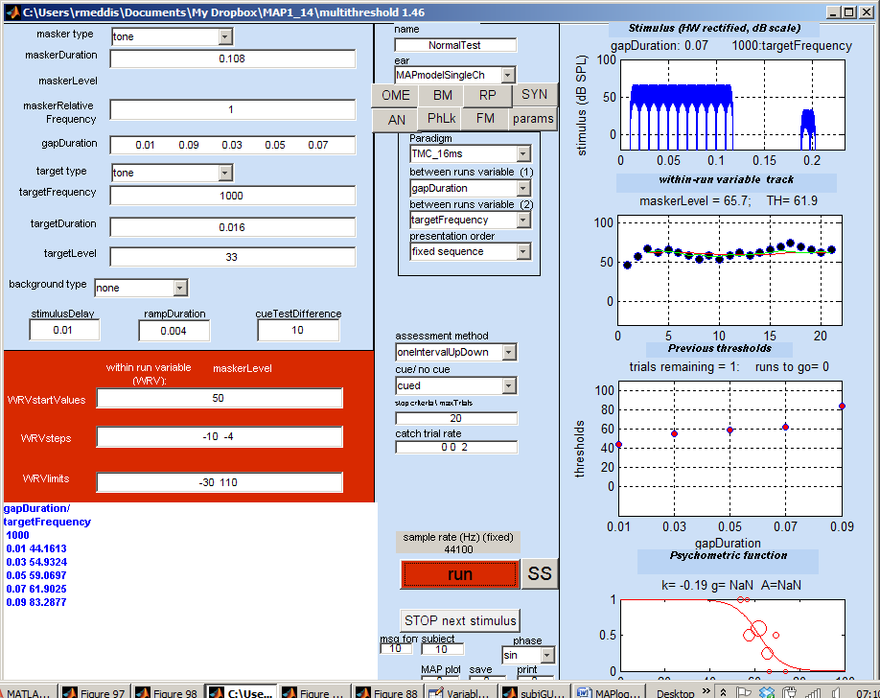 | thresholds  gapDuration/ targetFrequency  1000  0.01 44.1613  0.03 54.9324  0.05 59.0697  0.07 61.9025  0.09 83.2877
Regular probe
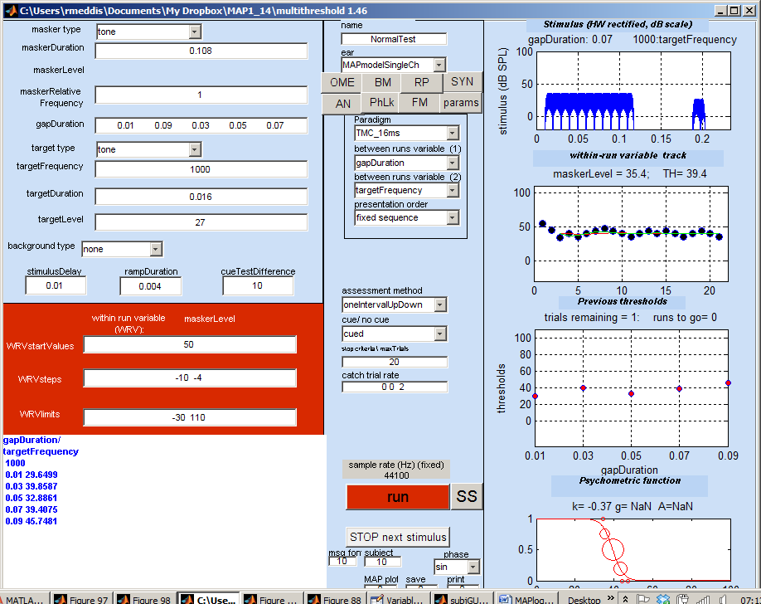 | thresholds  gapDuration/ targetFrequency  1000  0.01 29.6499  0.03 39.8587  0.05 32.8861  0.07 39.4075  0.09 45.7481

Restoring y to 4 and playing with b
B=8e-6 | 8 dB difference
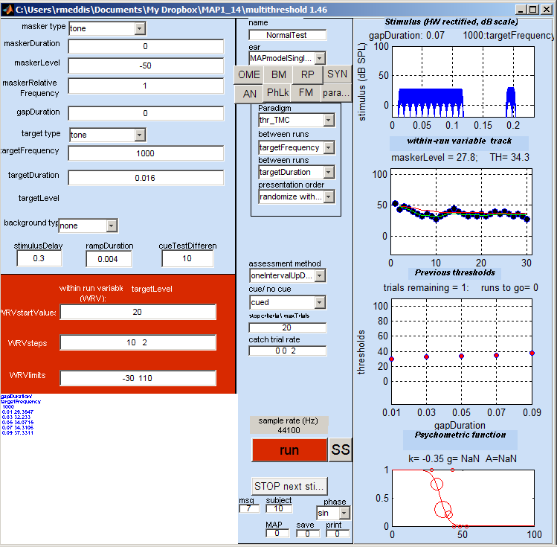 | thresholds  gapDuration/ targetFrequency  1000  0.01 29.3547  0.03 32.233  0.05 34.0715  0.07 34.3106  0.09 37.3311  paradigm: TMC_16ms  Elapsed time is 95.811962 seconds.  >>
B=12e-6 | 26 dB difference
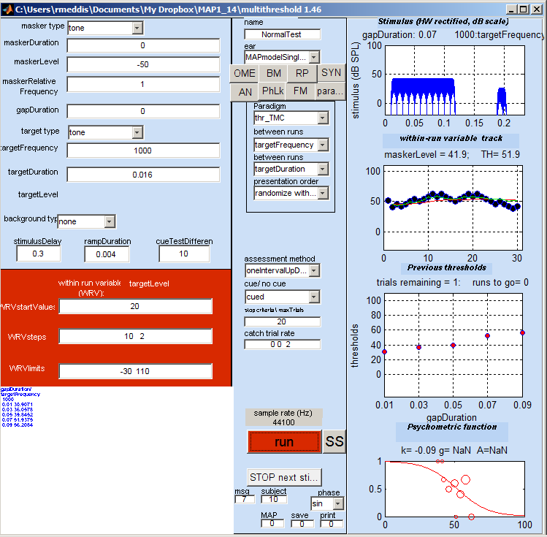 | thresholds  gapDuration/ targetFrequency  1000  0.01 30.9071  0.03 36.0578  0.05 39.8452  0.07 51.9375  0.09 56.2084  paradigm: TMC_16ms
B=12e-6 and a=0 and g=1000 (100 produces thresholds that are too high)

19th June changes
- Parameter changes are now handled in the MAPparams file rather than in the MAP1_14 function. paramChanges is passed to MAP1_14 as its final (optional) argument.
MAP1_14(inputSignal, sampleRate, BFlist, MAPparamsName, AN_spikesOrProbability, paramChanges)

These are then passed to the MAPparams call. When a request is passed to MAPparams to print the parameters, the changes are incorporated into the values printed and are highlighted separately at the bottom of the printout. All this has the advantage of holding all parameter handling in oneplace.
showMAP now needs parmChanges if it is to print out the correct set of parameters.
This opens the way to allow parameter changes in expGUI
- comparisonData has been removed from MAPparams. Experiment.comparisonData is now set to empty. This should be removed when all coding references have been deleted.
- MAP1_14 quick reference has been updated accordingly.
- A correction for refractory effects for probability calculations has been added at the end of MAP1_14. This is commented out at present but should work when uncommented. It slows the program down somewhat and has not been objectively tested as yet. A 250 ms tone into a 21 channel probability model took 2.9 s with refractory computations disabled (AN: 130.1086 max max AN: 1749.6301). Enabled it took 3.35 s (AN: 120.0084, max max AN: 1214.8144). That is 15% slower. The mean AN rate was reduced from 130 to 120 spikes/s and the epoch with the most spikes had 1750 spikes for the uncorrected compared with 1214 for the corrected.
Uncorrected  AN: 85.7949  max max AN: 923.1296  Elapsed time is 3.114862 seconds. | Corrected  AN: 81.4544  max max AN: 743.2567  Elapsed time is 3.427089 seconds.
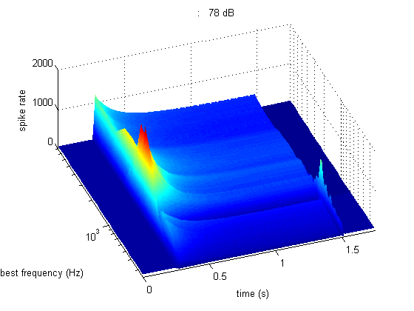 | 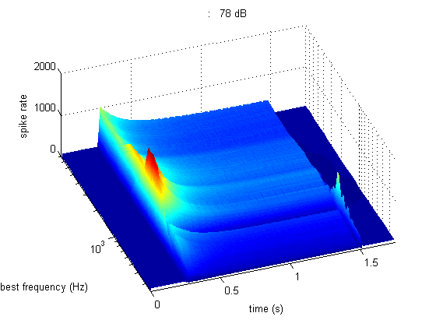

June 21
- MOCrateThreshold changed to MOCrateThresholdProb throughout.

June 22
- Fixed MOC attenuation can now be applied to MOC by making the factor negative.

June 23
- New parameters to improve physiological fit
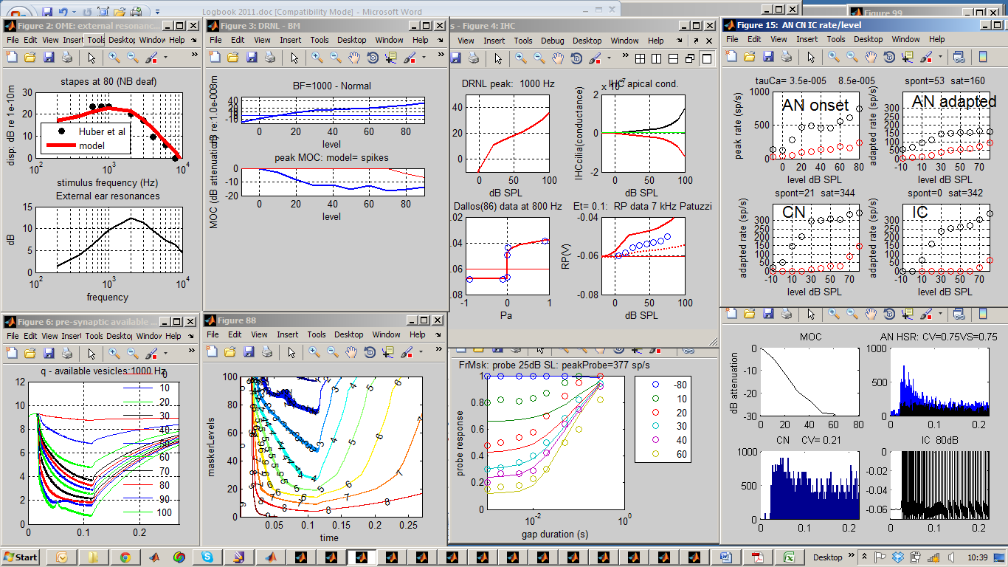
Normal

inputStimulusParams:
sampleRate= 44100 44100

OMEParams:
externalResonanceFilters= 10 10
OMEstapesLPcutoff= 1000 1000
stapesScalar= 4.50E-08 4.50E-08
rateToAttenuationFactor= 0.006 0.006
rateToAttenuationFactorProb= 0.01 0.01
ARtau= 0.05 0.05
ARdelay= 0.01 0.01
ARrateThreshold= 0 0

DRNLParams:
BFlist= 250... [21 element array] 250... [21 element array]
a= 30000 50000
b= 8.00E-06 8.00E-06
c= 0.2 0.2
nonlinCFs= 250... [21 element array] 250... [21 element array]
nonlinOrder= 3 3
nlBWs= 242.375... [21 element array] 242.375... [21 element array]
p= 0.2895 0.2895
q= 170 170
g= 100 100
linCFs= 336.655... [21 element array] 336.655... [21 element array]
linOrder= 3 3
linBWs= 263.275... [21 element array] 263.275... [21 element array]
MOCdelay= 0.01 0.01
rateToAttenuationFactor= 0.01 0.01
rateToAttenuationFactorProb= 0.0055 0.0055
MOCrateThresholdProb= 70 70
MOCtau= 0.1 0.1

IHC_cilia_RPParams:
tc= 0.0003 0.0003
C= 0.1 0.05
u0= 5.00E-09 5.00E-09
s0= 3.00E-08 3.00E-08
u1= 1.00E-09 1.00E-09
s1= 1.00E-09 1.00E-09
Gmax= 6.00E-09 5.00E-09
Ga= 8.00E-10 1.00E-09
Cab= 4.00E-12 1.00E-12
Et= 0.1 0.1
Gk= 2.00E-08 2.00E-08
Ek= -0.08 -0.08
Rpc= 0.04 0.04

IHCpreSynapseParams:
GmaxCa= 1.20E-08 1.20E-08
ECa= 0.066 0.066
beta= 400 400
gamma= 100 100
tauM= 5.00E-05 5.00E-05
power= 3 3
z= 2E+42 2E+42
tauCa= 3.50E-05 3.50E-05

AN_IHCsynapseParams:
M= 12 12
y= 6 6
x= 60 60
l= 250 250
r= 500 500
refractory_period= 0.00075 0.00075
numFibers= 100 100
TWdelay= 0.004 0.004
ANspeedUpFactor= 5 5

MacGregorMultiParams:
nNeuronsPerBF= 10 10
type= 'chopper cell' 'chopper cell'
fibersPerNeuron= 10 10
dendriteLPfreq= 50 50
currentPerSpike= 3.50E-08 3.00E-08
Cap= 1.67E-08 1.67E-08
tauM= 0.002 0.002
Ek= -0.01 -0.01
dGkSpike= 0.000133 0.000133
tauGk= 0.0005 0.0005
Th0= 0.01 0.01
c= 0 0
tauTh= 0.02 0.02
Er= -0.06 -0.06
Eb= 0.06 0.06
PSTHbinWidth= 0.0001 0.0001

MacGregorParams:
type= 'chopper cell' 'chopper cell'
fibersPerNeuron= 10 10
dendriteLPfreq= 100 100
currentPerSpike= 4.00E-08 3.00E-08
Cap= 1.67E-08 1.67E-08
tauM= 0.002 0.002
Ek= -0.01 -0.01
dGkSpike= 0.000133 0.000133
tauGk= 0.0005 0.0005
Th0= 0.01 0.01
c= 0 0
tauTh= 0.02 0.02
Er= -0.06 -0.06
Eb= 0.06 0.06
debugging= 0 0
wideband= 0 0
>>
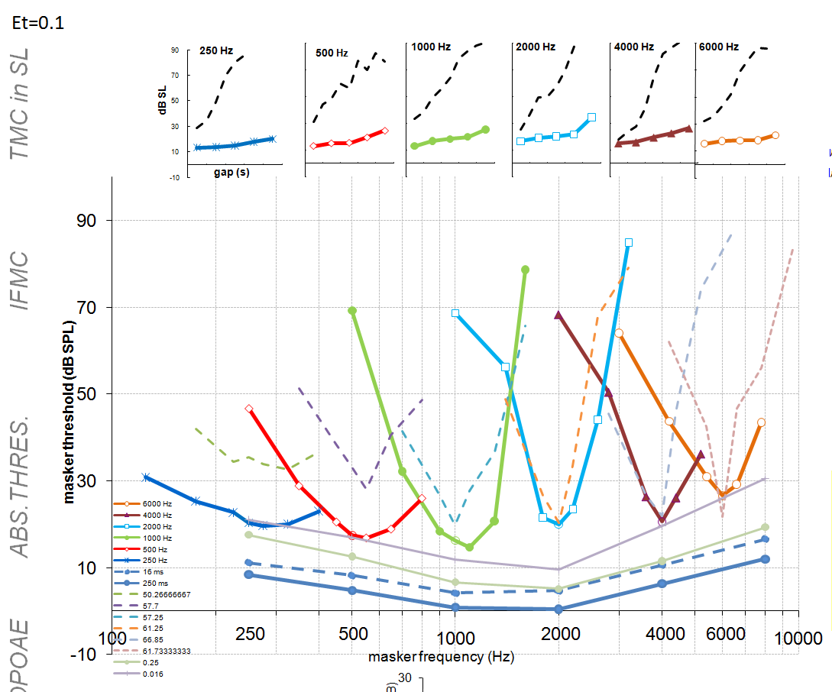

Diagnosis:
- Flat TMCs ?because probe too potent.
More changes
- A new routine has been added to multiThreshold to plot a complete profile 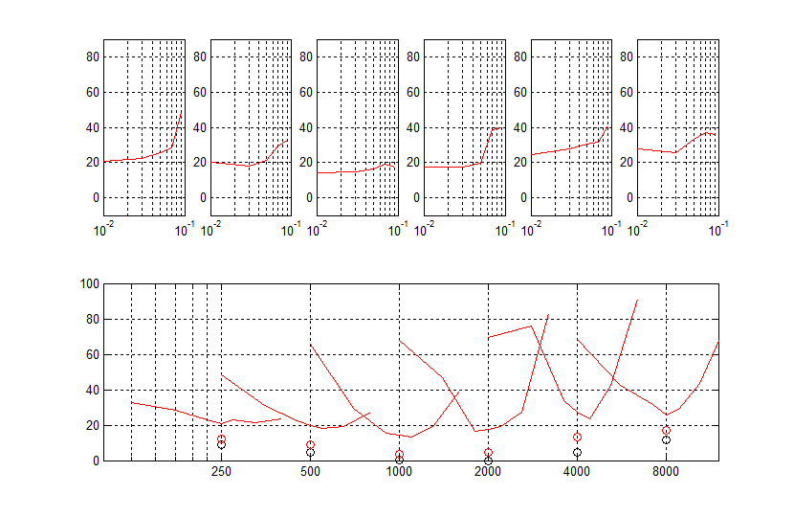
- Currently this works only with the paradigm thr_TMC and this needs to be tidied to create a new paradigm called ‘profile’.

June 24
- multiThreshold has been changed to allow threshold measurements to be made using the model in probability mode. This is superfast and gives results very similar to the spikes version. This is currently very untidy and needs to be sorted to work with 2AFC and multi-channel models
The pictures (spikes vs probability) compare reasonably well
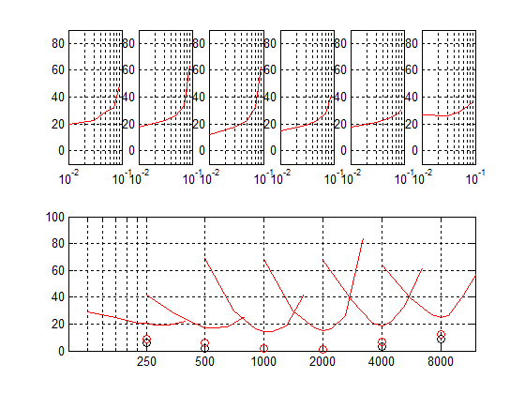
- decreasing the IHC stereocilia scalar to raise thresholds and we get

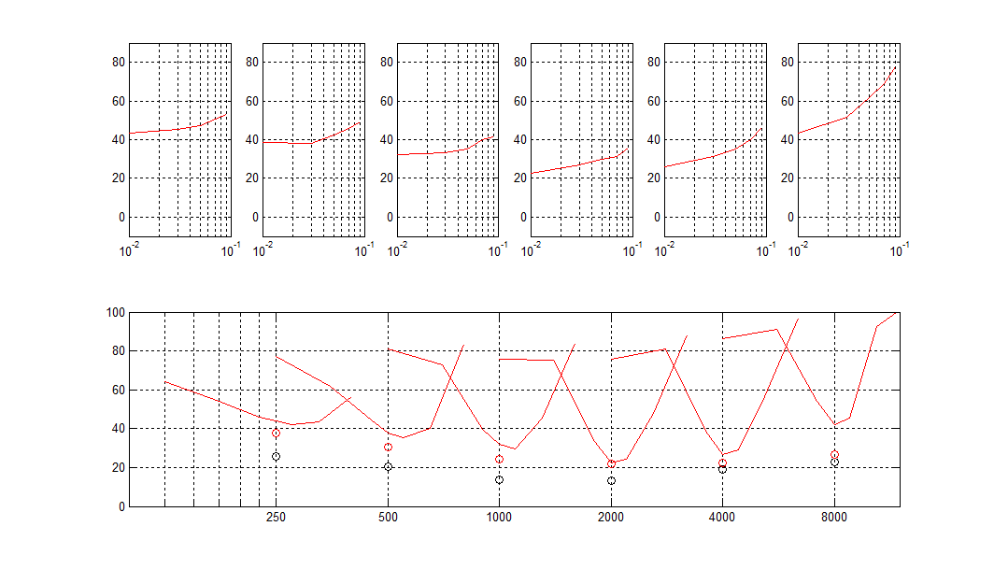

June 25
- multiThreshold has been adjusted to work with multichannel probability models by finding the channel with the best response during the probe presentation.
- plotProfile has been improved
- the-IFMC and thr-TMC paradigms are pensioned off and now completely replaced by the profile paradigm.
- Paradigms for TMC -16ms and IFMC -16 ms have also been removed. 16-ms is not the default for IFMC and TMC paradigms
- Stopping by request has been enabled for profile paradigm but the whole process for priming and triggering such stops needs investigation and tidying.
- Tails in the IFMCs found above are mysterious. Disabling the AR does not remove them
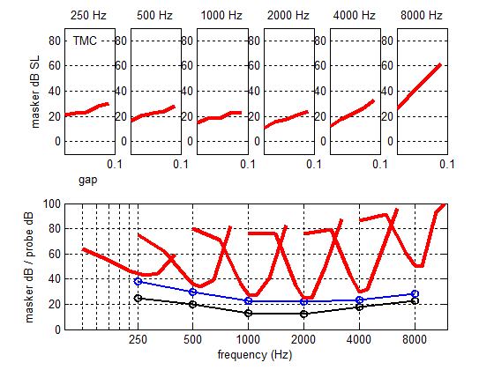
Instead the tails are removed when the linear pathway is disabled
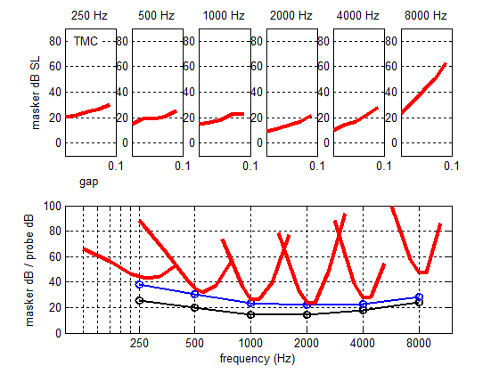
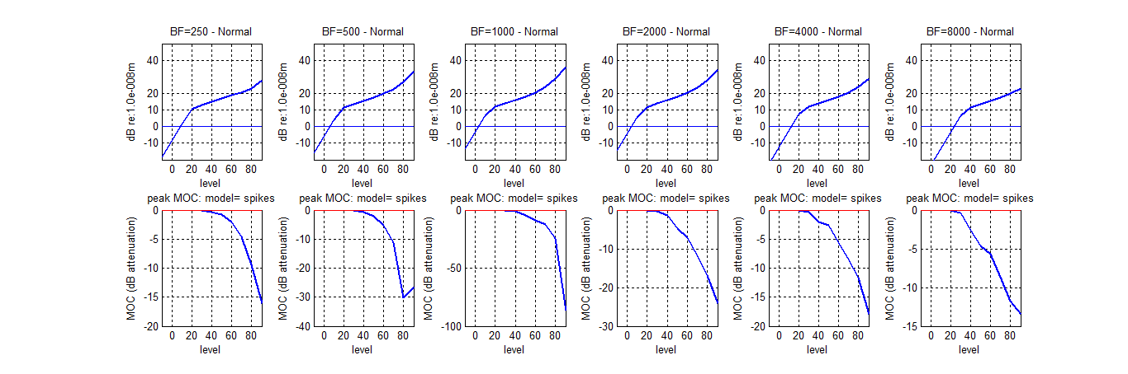
The BM now gives the wrong thresholds (out by 20 dB). Decrease a and increase C.
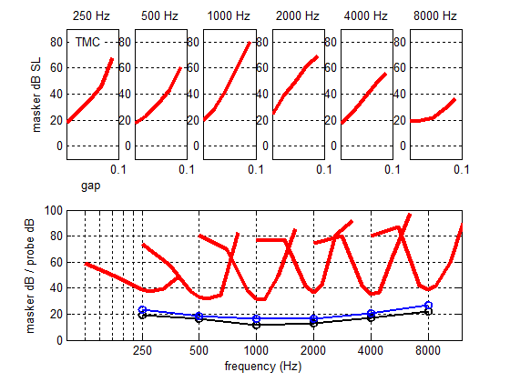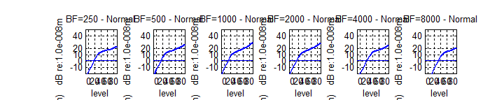
- Dashed lines now added to show normal data
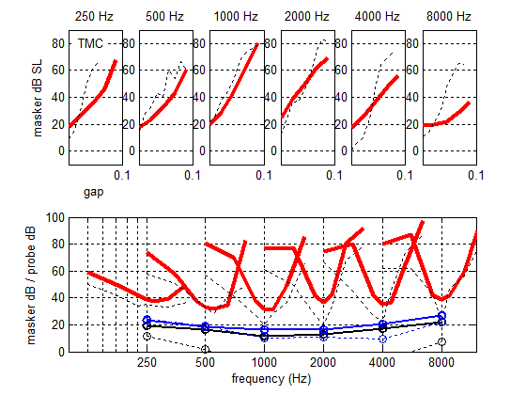

- Mt changed to allow parameter changes to be entered in a special edit box.
- MAPmodel function tidied up to eliminate references to method.

July 1
- testPhysiologyProb is a new test program to run all sensible test modules in probability mode. This is a fast check on the physiology. NB no phase locking
- testPhysiology still runs mainly in spikes mode (but synapse is still in probability mode).

July 4
- Reduced endocochlear potential produces anomalous results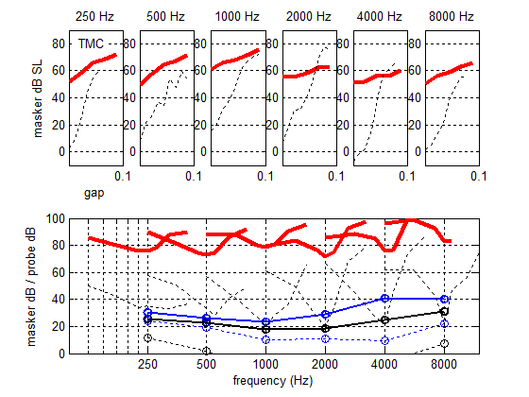
- Error trapping in ExpGUI adjusted so that it only picks up manual stopping
- !! physiology tests do not pick up paramChanges in EXPGUI
- ParamChanges now printed as part of the end of run report

July 7
- ExpGUI altered so that paramChanges are effective in physiology tests
- ParamChanges added to all functions relating to physiology tests
- paramChanges box now stays visible forever once modelling is selected.

July 12
- All paradigms altered so that they must declare whether the masker is used or not.
- stimulusPhase and randomizeSequence now always set as strings
- MAP 1_14 recoded to allow for multiple CNtau values.

